Unit 5
Software Analysis and Design Tools
Software analysis and design includes all activities, which help the transformation of requirement specification into implementation. Requirement specifications specify all functional and non-functional expectations from the software. These requirement specifications come in the shape of human readable and understandable documents, to which a computer has nothing to do. Software analysis and design is the intermediate stage, which helps human-readable requirements to be transformed into actual code.
Let us see few analysis and design tools used by software designers:

5.1 Data Flow Diagram
DFD is the abbreviation for Data Flow Diagram. The flow of data of a system or a process is represented by DFD. It also gives insight into the inputs and outputs of each entity and the process itself. DFD does not have control flow and no loops or decision rules are present.
It is a graphical tool, useful for communicating with users, managers and other personnel. it is useful for analyzing existing as well as proposed system. It is also known as bubble chart.
It provides an overview of:
- What data is system processes.
- What transformation are performed.
- What data are stored.
- What results are produced etc.
DFD Components
DFD can represent Source, destination, storage and flow of data using the following set of components -
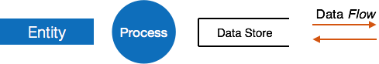
- Entities - Entities are source and destination of information data. Entities are represented by a rectangles with their respective names.
- Process - Activities and action taken on the data are represented by Circle or Round-edged rectangles.
- Data Storage - There are two variants of data storage - it can either be represented as a rectangle with absence of both smaller sides or as an open-sided rectangle with only one side missing.
- Data Flow - Movement of data is shown by pointed arrows. Data movement is shown from the base of arrow as its source towards head of the arrow as destination.
Levels in Data Flow Diagram
The DFD may be used to perform a system or software at any level of abstraction. Infact, DFDs may be partitioned into levels that represent increasing information flow and functional detail. Levels in DFD are numbered 0, 1, 2 or beyond. Here, we will see primarily three levels in the data flow diagram, which are: 0-level DFD, 1-level DFD, 2-level DFD. and
•DFD Level 0 is also called a Context Diagram. It’s a basic overview of the whole system or process being analyzed or modeled. It’s designed to be an at-a-glance view, showing the system as a single high-level process, with its relationship to external entities. It should be easily understood by a wide audience, including stakeholders, business analysts, data analysts and developers.
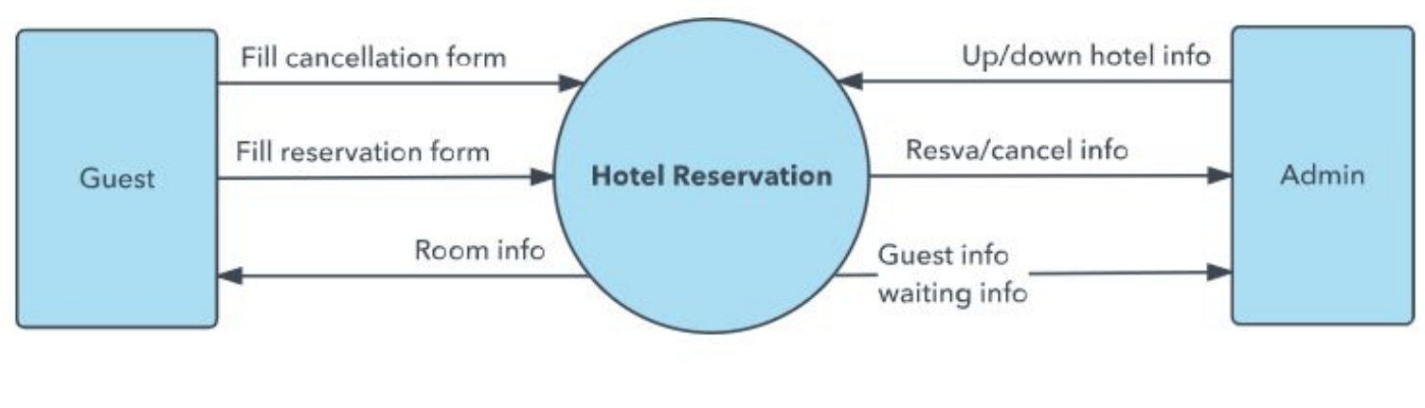
•DFD Level 1 provides a more detailed breakout of pieces of the Context Level Diagram. You will highlight the main functions carried out by the system, as you break down the high-level process of the Context Diagram into its sub processes.
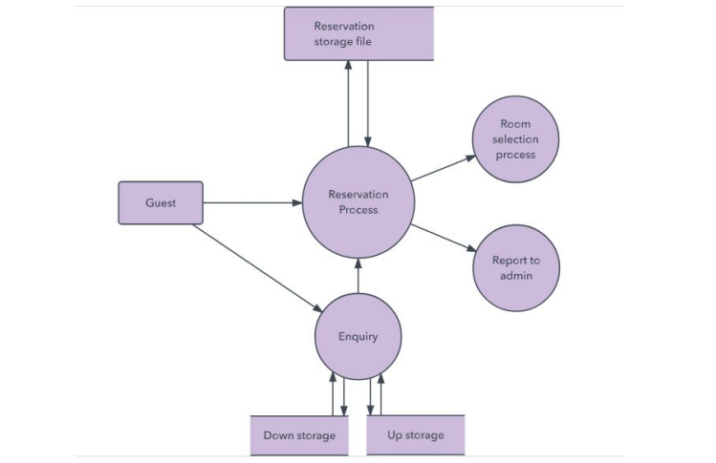
•DFD Level 2 then goes one step deeper into parts of Level 1. It may require more text to reach the necessary level of detail about the system’s functioning.

5.1.2 Entity Relationship (ER) Diagram
An ER diagram (Entity-Relationship diagram) is a graphical representation of entities and their relationships to each other, typically used in the design phase of a database.
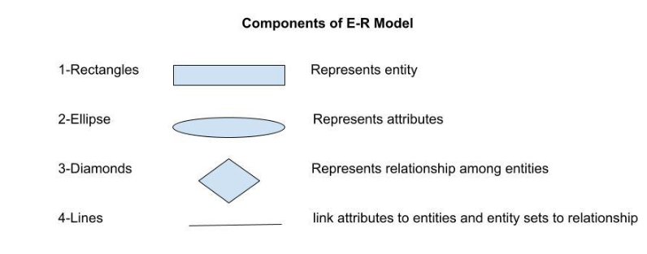
An Entity may be an object with a physical existence – a particular person, car, house, or employee – or it may be an object with a conceptual existence – a company, a job, or a university course.
Attribute(s):
Attributes are the properties that define the entity type. For example, Roll_No, Name, DOB, Age, Address, Mobile_No are the attributes that define entity type Student. In ER diagram, the attribute is represented by an oval.
Relationship
Relationships are represented by diamond-shaped box. Name of the relationship is written inside the diamond-box. All the entities (rectangles) participating in a relationship, are connected to it by a line.
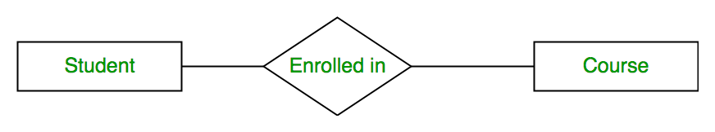
Cardinality
In one-to-one mapping cardinalities, an entity in A is associated with at most one entity in B, and an entity in B is associated with at most one entity in A.
Example:

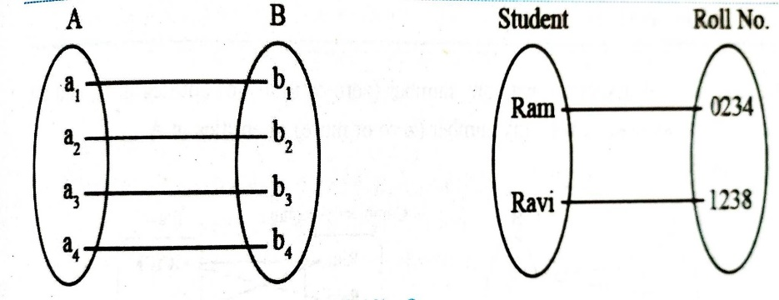

2.3.2 One to many
In one-to-many mapping cardinalities, an entity in A is associated with any number of entities in B, and an entity in B is associated with at most one entity in A.

Example:
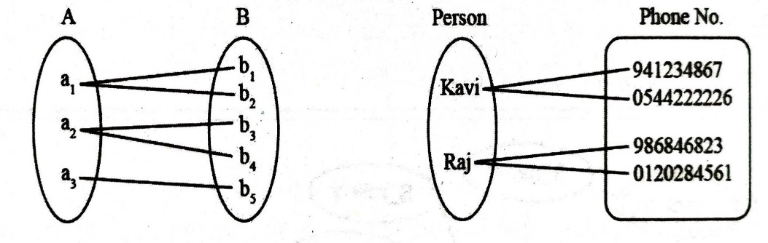

2.3.3 Many to one
In many-to-one mapping cardinalities, an entity in A is associated with at most one entity in B, and an entity in B is associated with any number of entities in A.
Example:
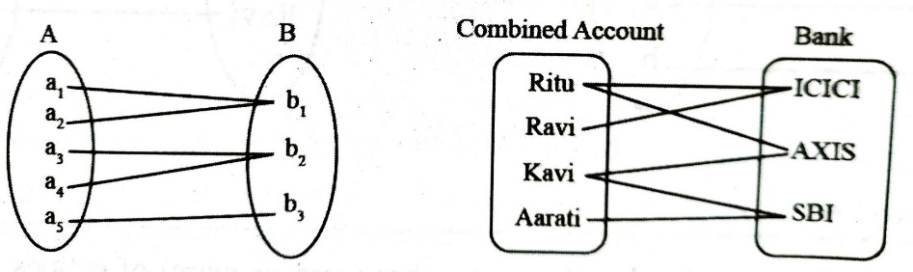

2.3.4 Many-to-many
In many-to-many mapping cardinalities, an entity in A is associated with any number of entities in B, and an entity in B is associated with any number of entities in A.
Example:
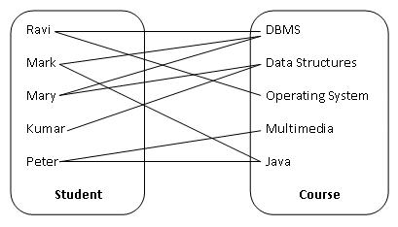

5.2 Structure Chart
Structure Chart represent hierarchical structure of modules. It breaks down the entire system into lowest functional modules, describe functions and sub-functions of each module of a system to a greater detail. Each module is represented by a box, which contains the module's name.
Symbols used in construction of structured chart:
Module
It represents the process or task of the system.
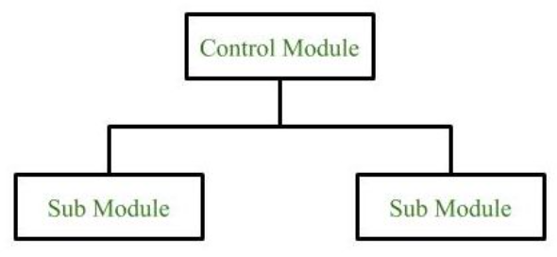
Conditional Call
It represents that control module can select any of the sub module on the basis of some condition.
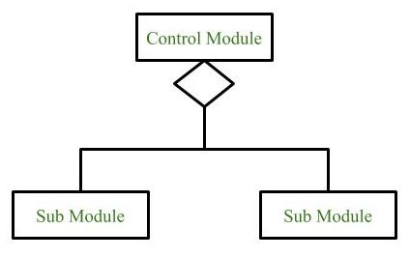
Loop (Repetitive call of module)
It represents the repetitive execution of module by the sub module.
A curved arrow represents loop in the module.
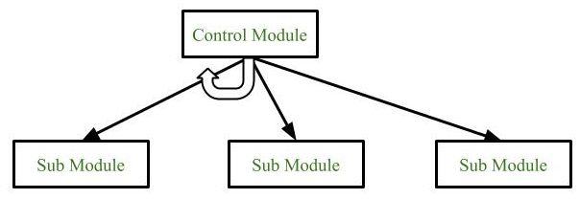
Data Flow
It represents the flow of data between the modules. It is represented by directed arrow with empty circle at the end.
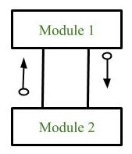

Control Flow
It represents the flow of control between the modules. It is represented by directed arrow with filled circle at the end.
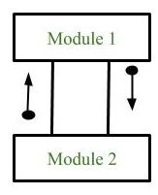
Physical Storage
Physical Storage is that where all the information are to be stored.
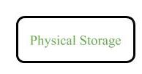
Example : Structure chart for an Email server
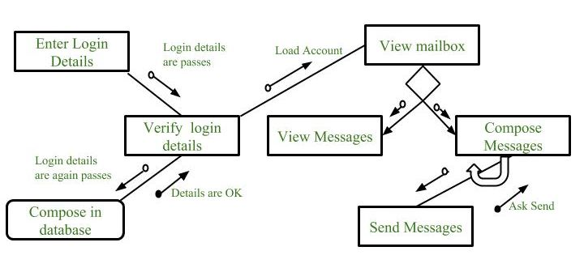
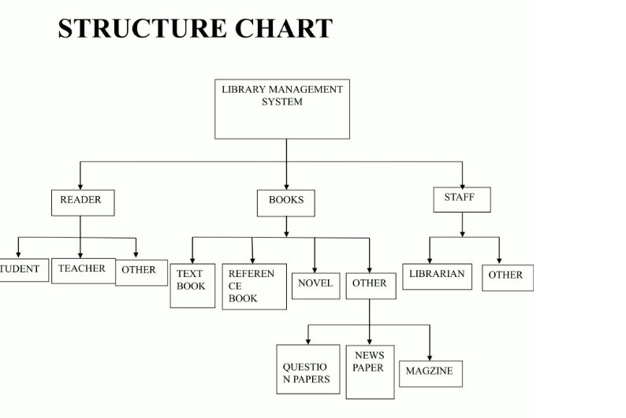

5.3 Decision Table
A decision table is a brief visual representation for specifying which actions to perform depending on given conditions. The information represented in decision tables can also be represented as decision trees or in a programming language using if-then-else and switch-case statements. A decision table typically consists of several columns, including:
Conditions: A list of conditions or circumstances that must be evaluated to determine the appropriate action.
Actions: The set of actions to be performed if the conditions are met.
Rules: A combination of conditions and actions that represent a specific business rule or decision.
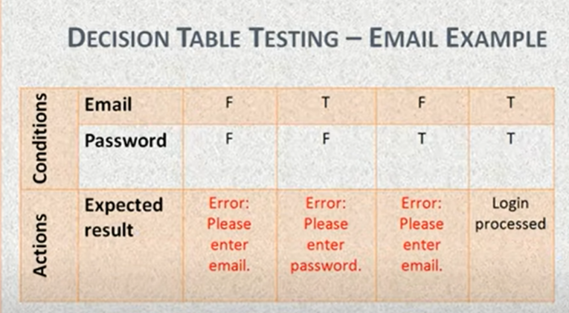

Importance of Decision Table:
- Decision tables are very much helpful in test design techniques.
- It helps testers to search the effects of combinations of different inputs and other software states that must correctly implement business rules.
- It assists in the development process with the developer to do a better job.
- A decision table is basically an outstanding technique used in both testing and requirements management.
- It is a structured exercise to prepare requirements when dealing with complex business rules.
Advantage of Decision Table:
- Any complex business flow can be easily converted into test scenarios & test cases using this technique.
- Decision tables work iteratively which means the table created at the first iteration is used as input tables for the next tables. The iteration is done only if the initial table is not satisfactory.
- Simple to understand and everyone can use this method to design the test scenarios & test cases.
- It provides complete coverage of test cases which helps to reduce the rework on writing test scenarios & test cases.

5.4 Decision Tree
A decision tree is a tree-like graph that is used in software engineering to model decision-making processes. It is a common tool in artificial intelligence and machine learning and is also widely used in other areas of software engineering, such as requirements analysis, testing, and quality assurance.
For example, consider Library Membership Automation Software (LMS) where it ought to support the following three options: New member, and Cancel membership. These are explained as following below.
1. New Member Option:
Decision:
Once the ‘new member’ possibility is chosen, the software system asks for details concerning the member just like the member’s name, address, number, etc.
Action:
If correct info is entered then a membership record for the member is made and a bill is written for the annual membership charge and the protection deposit collectible.
2. Cancel Membership Option:
Decision:
If the ‘cancel membership’ possibility is chosen, then the software system asks for a member’s name and his membership range.
Action:
The membership is off, the membership record is deleted from the information.
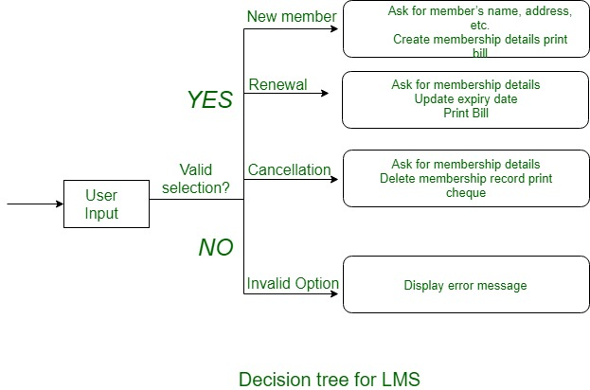

5.5 Use Case Diagram and Sequence diagram

5.5.1 Use Case Diagram
A use case diagram is used to represent the dynamic behavior of a system. It encapsulates the system's functionality by incorporating use cases, actors, and their relationships. The second thing which is relevant to use cases are the actors. Actors can be defined as something that interacts with the system.
Actors can be a human user, some internal applications, or may be some external applications. When we are planning to draw a use case diagram, we should have the following items identified.
- Functionalities to be represented as use case
- Actors
- Relationships among the use cases and actors.
Use case diagrams are drawn to capture the functional requirements of a system. After identifying the above items, we have to use the following guidelines to draw an efficient use case diagram
- The name of a use case is very important. The name should be chosen in such a way so that it can identify the functionalities performed.
- Give a suitable name for actors.
- Show relationships and dependencies clearly in the diagram.
- Do not try to include all types of relationships, as the main purpose of the diagram is to identify the requirements.
- Use notes whenever required to clarify some important points.
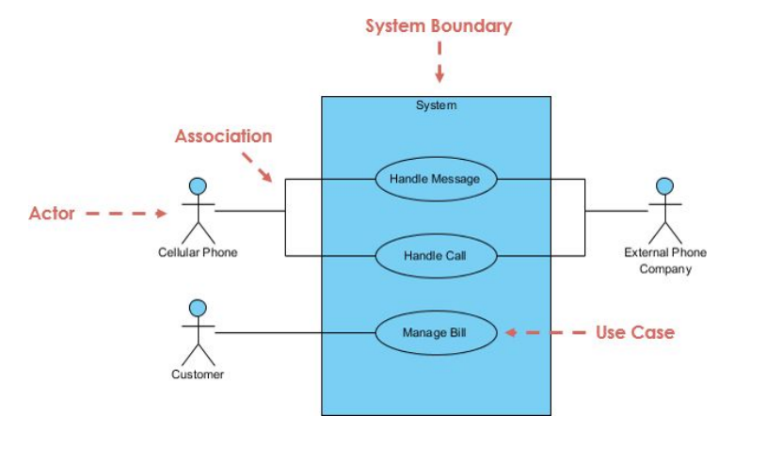

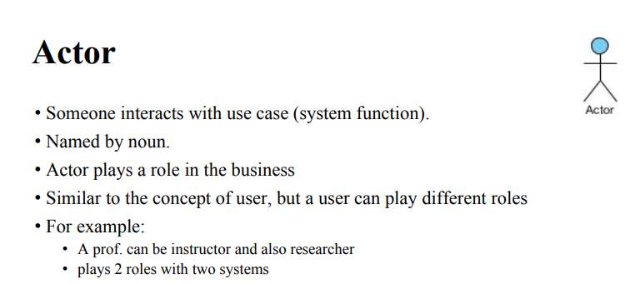

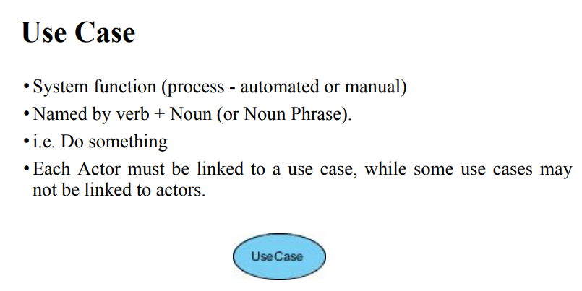
Include relationship:
An include relationship shows dependency between a base use case and an included use case.
Exclude relationship:
An include relationship shows dependency between a base use case and an included use case.
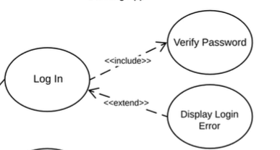

Validation and verification are two important concepts in software engineering that are often used interchangeably, but they have different meanings and purposes.
Verification is the process of ensuring that the software meets its specified requirements and works as expected. It involves testing the software at different stages of the development process to detect and fix any defects or errors. Verification is focused on checking that the software is doing what it was designed to do and that it meets the functional and non-functional requirements.
Validation, on the other hand, is the process of ensuring that the software meets the needs of the users and is fit for its intended purpose. Validation is focused on checking whether the software satisfies the customer's needs and requirements, and whether it is usable and effective in the real world. It involves testing the software in a realistic environment and with realistic data, and it includes activities such as usability testing, user acceptance testing, and performance testing.
In summary, verification is about checking whether the software works as expected, while validation is about checking whether the software meets the customer's needs. Both verification and validation are important in software engineering to ensure the quality and reliability of the software.

5.5.2 Sequence Diagram
A Sequence Diagram is a key component of Unified Modeling Language (UML) used to visualize the interaction between objects in a sequential order. It focuses on how objects communicate with each other over time, making it an essential tool for modeling dynamic behavior in a system. Sequence diagrams illustrate object interactions, message flows, and the sequence of operations, making them valuable for understanding use cases, designing system architecture, and documenting complex processes.
Purpose of Sequence Diagram
- To model high-level interaction among active objects within a system.
- To model interaction among objects inside a collaboration realizing a use case.
Notation of a Sequence Diagram
Lifeline
An individual participant in the sequence diagram is represented by a lifeline. It is positioned at the top of the diagram.

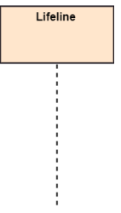

Actor
A role played by an entity that interacts with the subject is called as an actor. It is out of the scope of the system. It represents the role, which involves human users and external hardware or subjects.
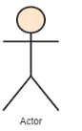
Activation
It is represented by a thin rectangle on the lifeline. It describes that time period in which an operation is performed by an element, such that the top and the bottom of the rectangle is associated with the initiation and the completion time, each respectively.
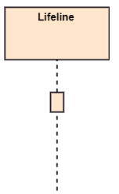

Messages
Communication between objects is depicted using messages. The messages appear in a sequential order on the lifeline.
- We represent messages using arrows.
- Lifelines and messages form the core of a sequence diagram.
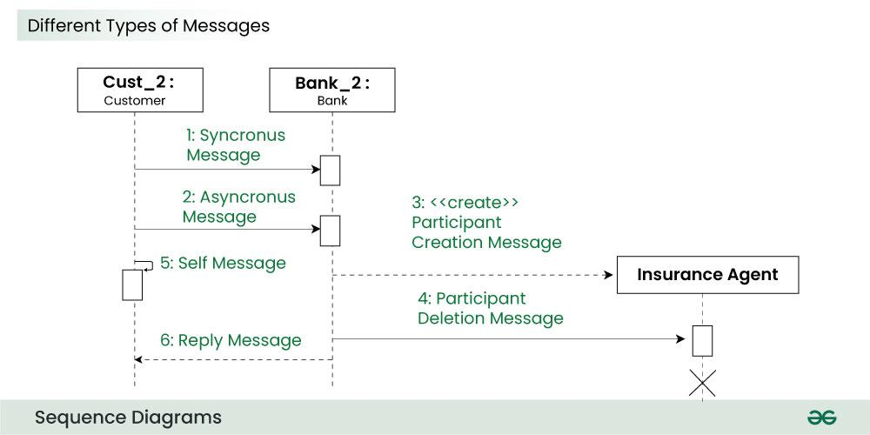
Messages can be broadly classified into the following categories:
1. Synchronous messages
A synchronous message waits for a reply before the interaction can move forward. The sender waits until the receiver has completed the processing of the message. The caller continues only when it knows that the receiver has processed the previous message i.e. it receives a reply message.
- A large number of calls in object oriented programming are synchronous.
- We use a solid arrow head to represent a synchronous message.
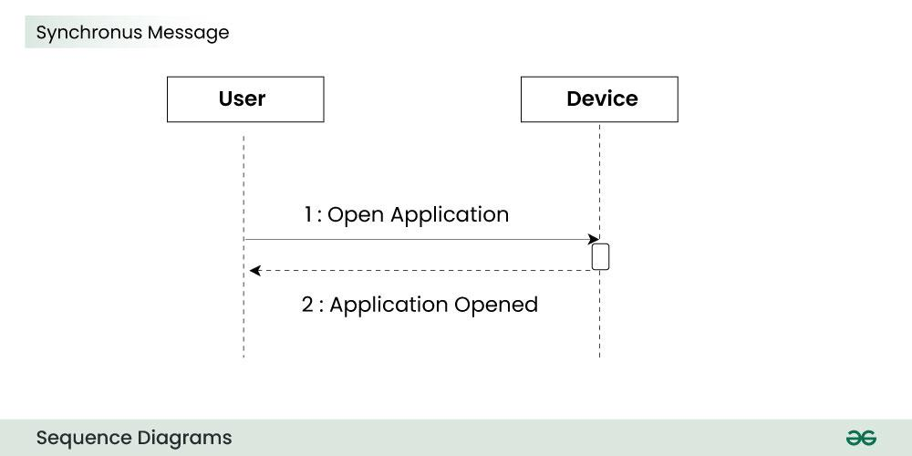
2. Asynchronous Messages
An asynchronous message does not wait for a reply from the receiver. The interaction moves forward irrespective of the receiver processing the previous message or not. We use a lined arrow head to represent an asynchronous message.
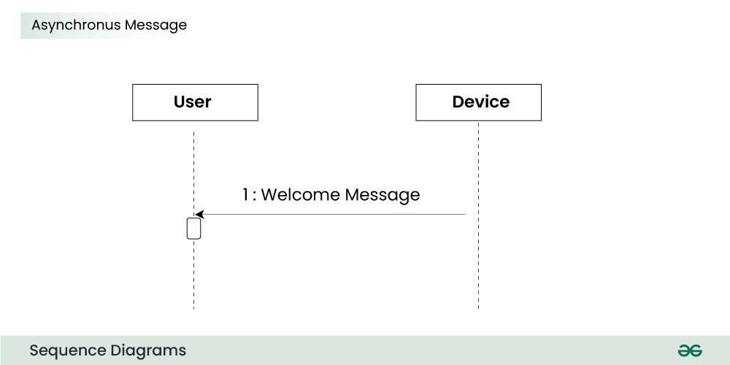
4. Create message
We use a Create message to instantiate a new object in the sequence diagram. There are situations when a particular message call requires the creation of an object. It is represented with a dotted arrow and create word labelled on it to specify that it is the create Message symbol.
For example:
The creation of a new order on a e-commerce website would require a new object of Order class to be created.
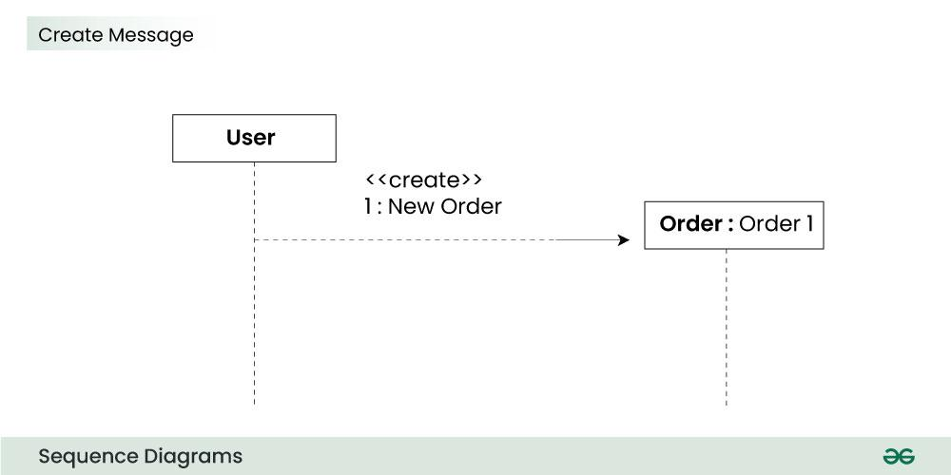
5. Delete Message
We use a Delete Message to delete an object. When an object is deallocated memory or is destroyed within the system we use the Delete Message symbol. It destroys the occurrence of the object in the system.It is represented by an arrow terminating with a x.
For example:
In the scenario below when the order is received by the user, the object of order class can be destroyed.
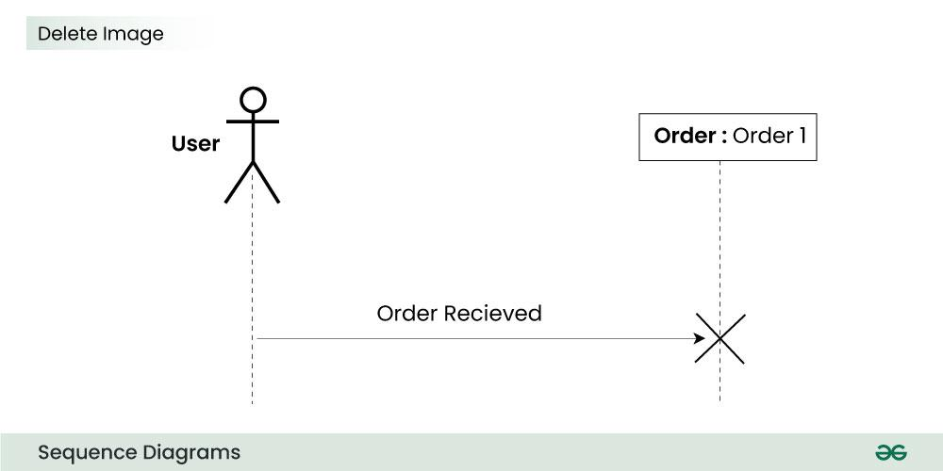
6. Self Message
Certain scenarios might arise where the object needs to send a message to itself. Such messages are called Self Messages and are represented with a U shaped arrow.
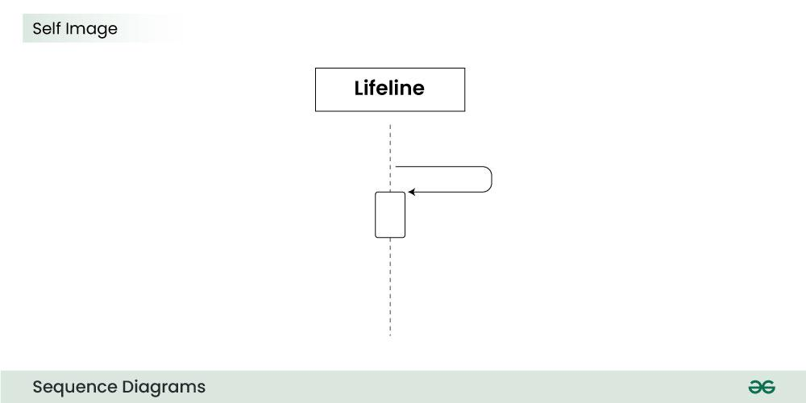
For example:
Consider a scenario where the device wants to access its webcam. Such a scenario is represented using a self message.
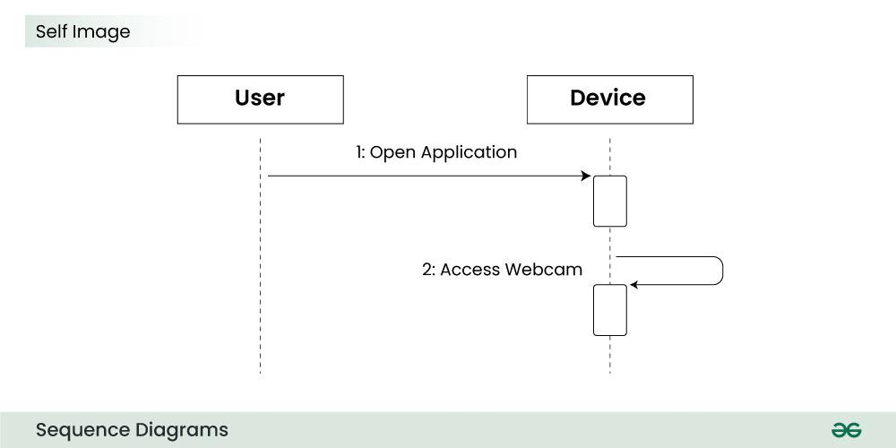
7. Reply Message
Reply messages are used to show the message being sent from the receiver to the sender. We represent a return/reply message using an open arrow head with a dotted line. The interaction moves forward only when a reply message is sent by the receiver.
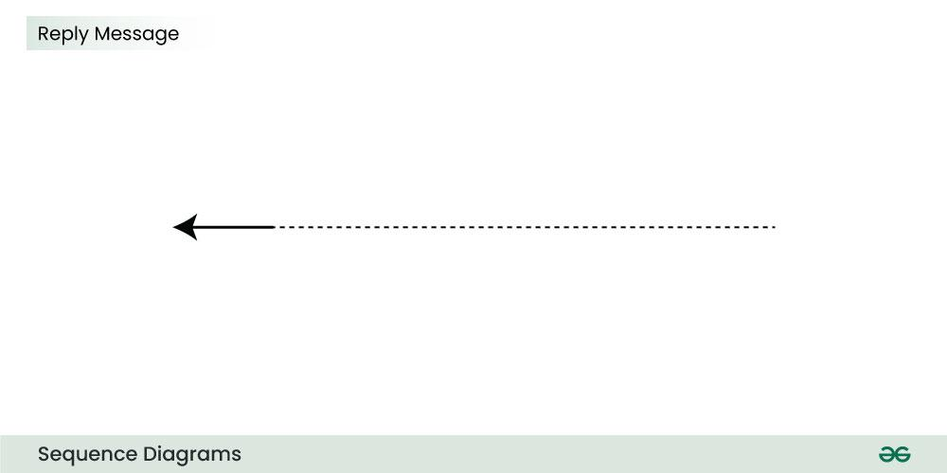

The messages depict the interaction between the objects and are represented by arrows. They are in the sequential order on the lifeline. The core of the sequence diagram is formed by messages and lifelines.

